  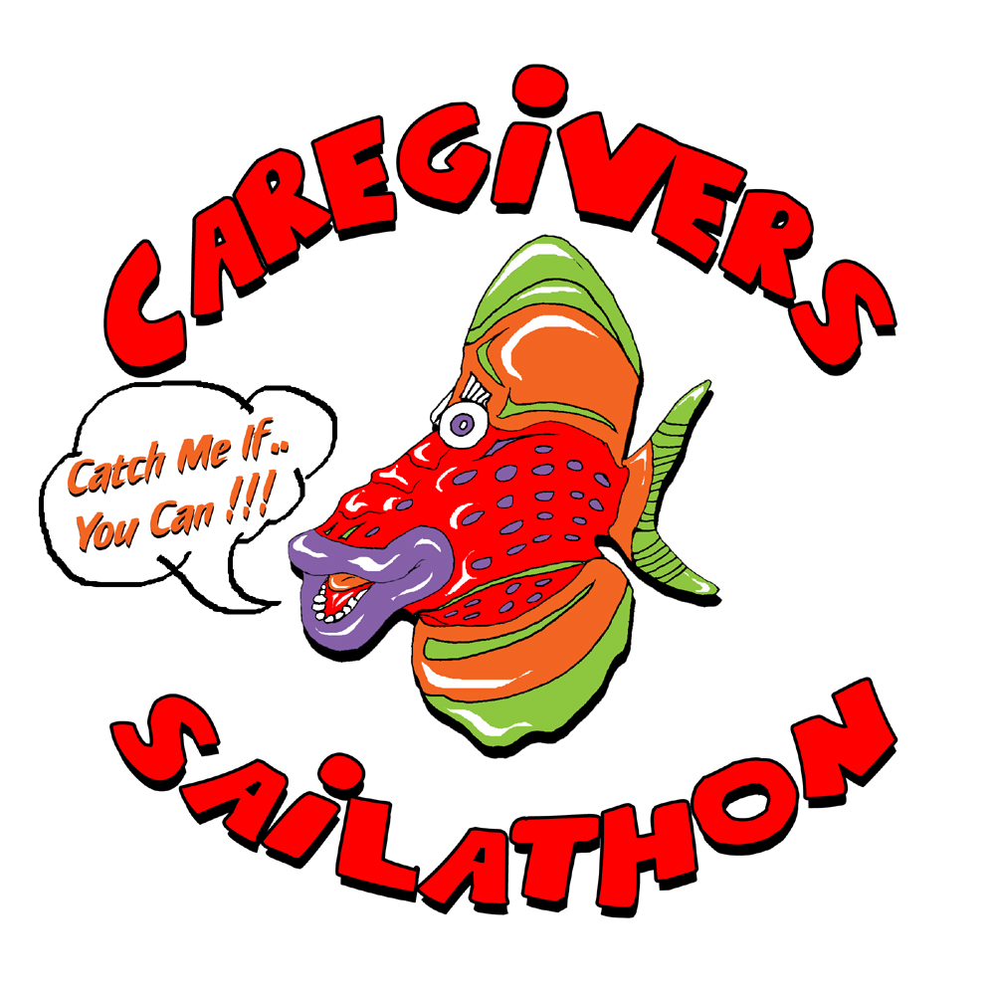 | Annual SAILATHON  Skipper’s Pledge Form  Channel Islands Harbor / Ventura Harbor | CAREGIVERS: Volunteers Assisting the Elderly is a 501(c) 3 nonprofit agency that promotes the health, well-being, dignity and independence of frail, homebound elders through one-on-one relationships developed with trusted volunteers.

Name: | Boat Name: |  | Sail# | CF#
Company:
Street Address:
City: |  | Zip Code:
Phone: |  | E-mail:

CAPTAIN’S PLEDGE: As SKIPPER / OWNER I will contribute $___________ to CAREGIVERS for every lap we complete or a flat donation of $____________.

Listed below are my FRIENDS, FAMILY, & BUSINESS ASSOCIATES, who support this effort of my boat and crew with a pledge for each lap completed or with a flat donation.

Please Print
Sponsor’s Name | Address/City/Zip  For Thank You Letters & Receipt | Pledge Per Lap | # Laps | Donation | Total:  - Pledge  - Donation | Received:    (Office Use)
 |  | $ |  | $ | $
 |  | $ |  | $ | $
 |  | $ |  | $ | $
 |  | $ |  | $ | $
 |  | $ |  | $ | $
 |  | $ |  | $ | $
 |  | $ |  | $ | $
 |  | $ |  | $ | $
 |  | $ |  | $ | $
 |  | $ |  | $ | $
 |  | $ |  | $ | $
 |  | $ |  | $ | $
 |  | $ |  | $ | $
 |  | $ |  | $ | $
 |  | $ |  | $ | $
 |  | $ |  | $ | $

Make Checks Payable To: CAREGIVERS: Volunteers Assisting the Elderly | Total Collected: | $

CAREGIVERS: Volunteers Assisting the Elderly is 501 (c) 3 Non-Profit Agency serving homebound and frail seniors.
Your donation is tax deductible to the full extent of the law. Tax ID #77-0081692 (www.vccaregivers.org) .

